Ice Hop

Game Template

Game documentation and How To guide.

# **Ice Hop is a full Unity template ready for release. It is fun arcade game. It is compatible with mobile( iOS and Android) as well as standalone and webplayer.**

**How to Play?**

Mobile: Touch Left side of the screen for a small jump and Right side of the screen for big jump.

Others: Press Left arrow key for a small jump and Press Right arrow key for big jump.

**How the game works**

The base below player is iceberg floor and 1 iceberg floor consist of 5 iceberg .there are 4 iceberg floor prefab and in each floor some icebergs are missing creating gap between 2 iceberg. Randomly these floors get instantiated. Left key makes the player jump the distance of 1 iceberg and when there is a gap the player has to jump with twice power and right key does it. After every jump speed increases making it difficult to choose whether to use left or right key . which makes the so intresting, fun and hard.

**Please rate my file, I’d appreciate it :)**

Customization Guide

First of all, you have to get [DOTWEEN](http://u3d.as/aZ1) from the Asset Store :

<http://u3d.as/aZ1>

(it’s free)

1/ Import Dotween from the asset store : <http://u3d.as/aZ1>



2/ Import the package into Unity

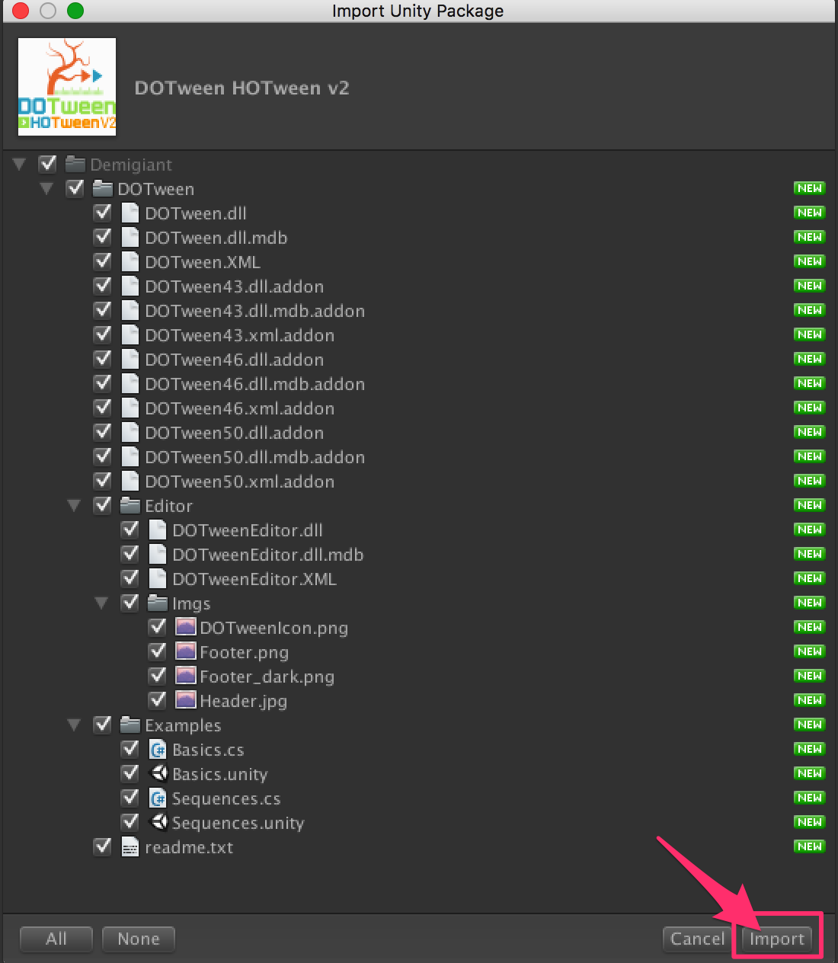

3/If you don’t see the « Tools » in the top of the Unity Screen, please do this :

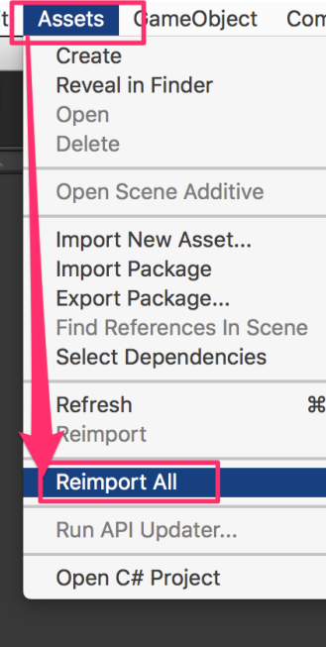

4/Now you have the « Tools ». Open it and click on « DOTween Utility Panel ».

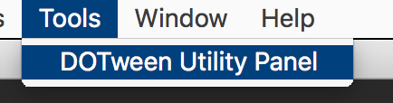

5/Click on « Setup DOTween ».

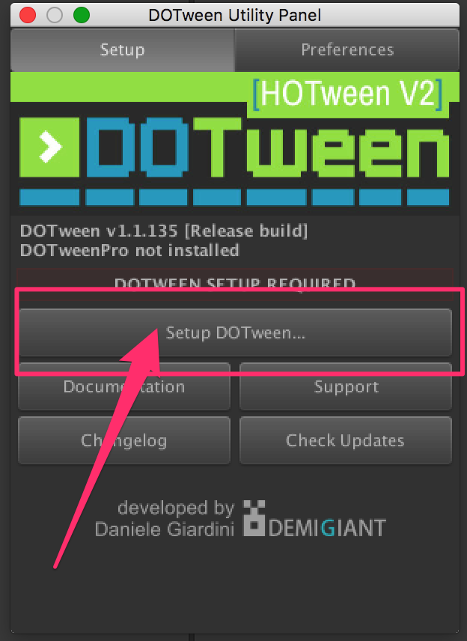

6/And to finish, click on the « OK » button.

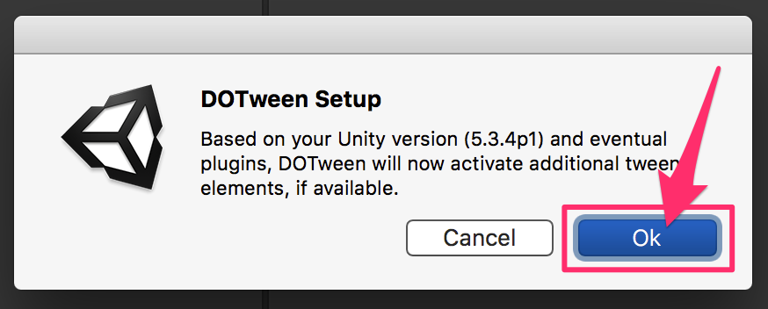

GameController

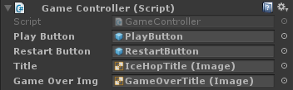

**Play Button:** contains play game button.

**Restart Button:** contains restart game button.

**Title:** contains the Ice Hop Title image.

**Game Over Img:** contains game over title image.

IceBerg Generation

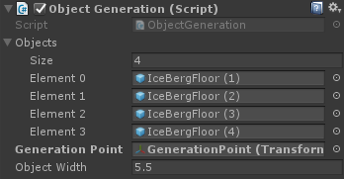

**Objects:** contains all different type of iceberg floor.

**Generation Point:** The point after where new iceberg floors are generated(present in main camera).

**Object width:** the total width of iceberg floor so next floor can be instantiated exactly after the current one.

Water Generation

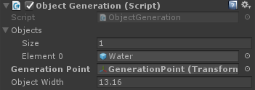

**Objects:** contains the water prefab.

**Generation Point:** The point after where another water prefab is generated(present in main camera).

**Object width:** the total width of water prefab so next prefab can be instantiated exactly after the current one.

Player

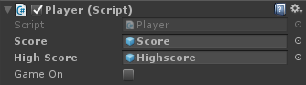

**Score , High score:** Contains score and highscore text.

SFX Manager

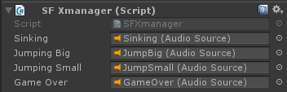

**Contains all the audio files.**

For any inquiry contact: **aakarshak51@gmail.com**